4.NBT.B.5: Multiply Four by One and Two by Two Digit Numbers

**Target Grade: 4th**

**Common Core Domain:** Number and Operations in Base 10

**Common Core Cluster:** Use Place Value Understanding And Properties Of Operations To Perform Multi-Digit Arithmetic.

**Standard: 4.NBT.B.5**

Multiply a whole number of up to four digits by a one-digit whole number, and multiply two two-digit numbers, using strategies based on place value and the properties of operations. Illustrate and explain the calculation by using equations, rectangular arrays, and/or area models.

**MAIN CONCEPTS**

* Multiply a whole number of up to four digits by a one-digit whole number using strategies based on place value.
* Multiply a whole number of up to four digits by a one-digit whole number using strategies based on the properties of operations.
* Multiply two two-digit numbers using strategies based on place value and the properties of operations.
* Multiply a whole number of up to four digits by a one-digit whole number using strategies based on place value and the properties of operations.
* Explain multiplication of a whole number up to four digits by a one-digit whole number and of two two-digit numbers by using equations, rectangular arrays, and/or area models.
* Represent multiplication using arrays.

**Clarifications, limits, emphases, and other information intended to ensure**

**appropriate variety in tasks:**

* Avoid the use of the standard algorithm.

**About the Math**

Multiplication can be represented by arrays, area models, or by equal jumps on a number line. Note that as factors change the notion of repeated addition loses its value and efficiency. Use of repeated addition with multi-digit factors should be avoided. In order to teach the multiplication algorithm in 5th grade with understanding, models must be used to explain the procedure for using the standard algorithm. The area model can be used to model partial products. Students should also record partial products with equations or the partial products algorithm.

There is a clear progression of the size of factors across grade 4 beginning with 2-digit factors and proceeding to 3 and 4-digits.

* Use partial products to multiply a multi-digit factor by a one-digit factor (decomposing one or both factors).

We can decompose one or both factors to find partial products. Factors can be decomposed in a myriad of ways. Students should be able to justify the decompositions that they make. For example, 26 x 4 can be thought of as (20 x 4) + (6 x 4). However, it is likely more efficient to think of it as (25 x 4) + (1 x 4).

* Explain and represent multiplication of a two-digit factor by a two-digit factor.
* Use partial products to multiply a two-digit factor by a two-digit factor (decomposing one or both factors).

Multiplication in grade 4 progresses to two, two-digit factors. Students should use partial products with these factors. One or both factors can be decomposed. It makes sense to decompose both factors at first before beginning to work with the decomposition of one (as appropriate).

* Write an equation for multiplication situations.

Students represent multiplication situations and problems with equations. Students should connect their equations to their representations and problems. This is especially needed for developing an understanding of partial products.

**Area Model Example**

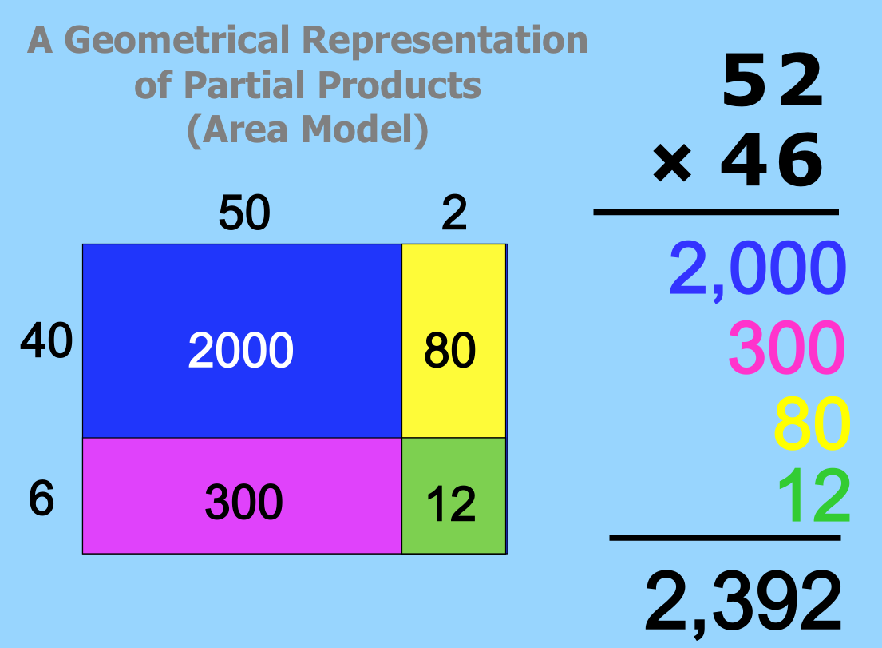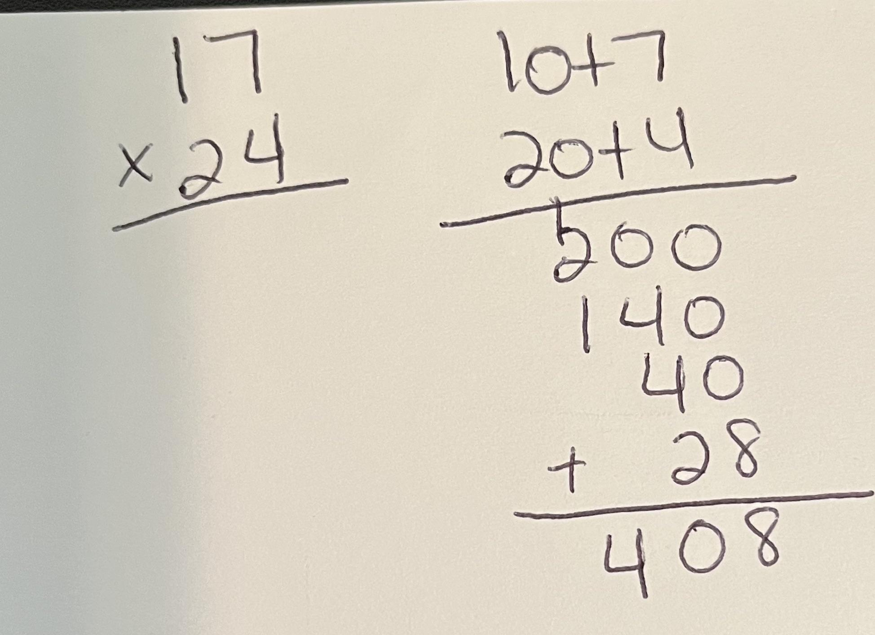

**Place Value or Partial Products Example**

**Relationship to Mathematical Practice:**

* [CCSS.MATH.PRACTICE.MP7](http://www.corestandards.org/Math/Practice/MP7/) Look for and make use of structures

**Additional Resources:**

* <https://hcpss.instructure.com/courses/107/pages/4-dot-nbt-dot-5-about-the-math-learning-targets-and-rigor> (watch the video at the bottom of the page)
* [IXL](https://www.ixl.com/standards/common-core/math/grade-3) – see main concepts and hover over each to see example problems
* <https://www.engageny.org/ccls-math/4nbt5>
* <https://achievethecore.org/peersandpedagogy/misunderstood-math-standards-grade-4/>